European HPC Summit Week 2017

Barcelona, 15 – 19th May 2017
OPEN CALL for expression of interest

TABLE OF CONTENT
EXECUTIVE SUMMARY 3
1. INTRODUCTION 4
2. letter of interest 5

EXECUTIVE SUMMARY
EXDCI is pleased to announce an open call for HPC stakeholders (institutions, service providers, users, communities, vendors and consultants) to shape and contribute the ongoing European HPC Summit Week event series. This conference series started its first edition in 2016 with the organization of the European HPC Summit Week 2016 that was held in Prague, Czech Republic.
This document pretends to define all possible participants interested in including an event or workshop under the European HPC Summit Week 2017 that will take place 15 – 19th May 2017 at the Vertex Building, UPC North Campus in Barcelona. The procedure is to send an expression of interest to have an event/workshop and agree on a joint programme for this week.

INTRODUCTION
The overview of the past event of this week was the following one:
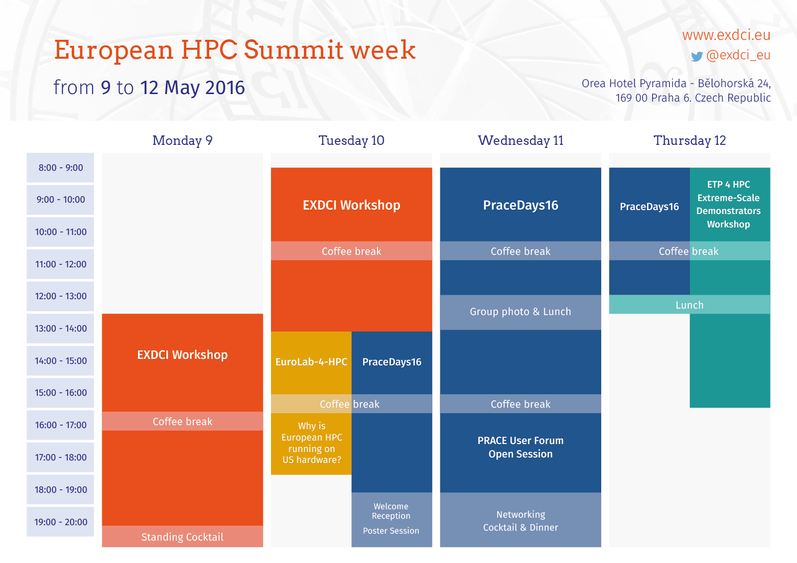
In its first edition, the full week included various events or workshops as well as other private meetings organized during the week.
The aim of the European HPC Summit Week series is to gather all related European initiatives and actors related to HPC in a single week. The idea is to gather the main HPC actors in a week in order to find synergies among all HPC initiatives. Ideally, its location should modify each year in Europe. An open tender will be launched to host this week each year.
Each individual event or workshop under this European HPC Summit Week should be in charge of their own agenda and assign a unique final responsible for EXDCI, as well as run their own costs (catering services, room, etc.). The week will count with a unique fee and registration form for all attendees and it pretends to cover the costs of the rooms, WIFI, registration desk, printing materials, etc.

letter of interest
If you are an HPC project, initiative or company and you want to include a workshop or event under the European HPC Summit Week, please send the following details to Renata Giménez (renata.gimenez@bsc.es) as the event coordinator:
- Contact details including
  - Name(s) of the responsible of the project,
  - Email address and phone number
- Project title, short description and URL
- Title and short summary of the event
- Duration of your event and indicate your preferred dates included in the week from the 15th until 19th May 2016 (your preferred dates will be taken into account but we cannot guarantee that they will be the final dates)
- Facilities you need:
  - number of attendees expected,
  - rooms needed,
  - layout of the room (theatre, classroom, U-format)
  - Catering services (coffee and lunch breaks, cocktails, etc.)
  - Supporting documentation needed
  - Any other comments
The deadline for this 'expression of interest' for the European HPC Summit Week 2017 is Monday 4th July 2016 midday CEST.

