European HPC Summit Week 2018

Ljubljana 28 May – 1 June 2018
Call for Workshops

INTRODUCTION

The aim of the European HPC Summit Week series is to gather all European initiatives and actors related to HPC in a single week, to find synergies among all HPC initiatives. The PRACE Scientific and Industrial Conference – PRACEdays – forms the central event of the Week.

This document details the Open Call for Workshops meant to provide possibilities to CoEs, FET HPC Projects, and other actors from the HPC ecosystem to co-locate their workshops and sessions.

Each individual session or workshop under the European HPC Summit Week is in charge of their own agenda and should assign a meeting responsible / meeting organiser. The week will charge a single fee (€ 60 all-inclusive) and provide a single registration form for all attendees.

Questions can be sent to: François Bodin francois.bodin@irisa.fr

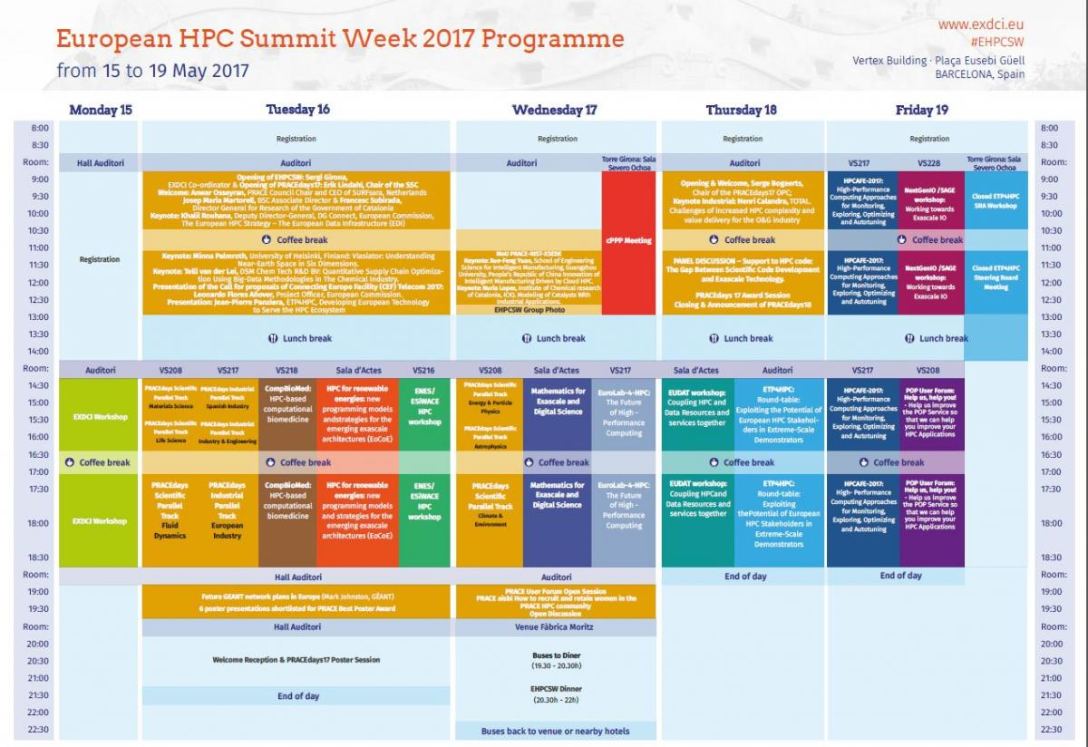
Figure 1 – The European HPC Summit Week in 2017

Call For Workshops

EHPCSW 2018 offers opportunities to host half-day workshops for CoEs, FET HPC Projects, and other HPC actors. These workshops will be held on 29 and 30 May 2018. The programme offers space to host 8 parallel tracks on each day including a maximum of 10 workshops during the entire week. A workshop will be assigned one room according to the number of expected attendees. Workshops that require multiple rooms cannot be accepted.

Workshop proposals must be submitted via the conference website at https://events.prace-ri.eu/event/ehpcsw2018/

Important Dates

- Submission date: 18 December 2017
- Notification of acceptance: 12 January 2018
- Applicants can decline their accepted workshop until 19 January 2018. After this date, costs will be charged to the organiser as if the workshop had taken place.

Submission & Review Process

Submissions content

Please fill out all parts of the online application form, and be sure to include:
- Project title and URL (if applicable)
- Abstract & keywords (maximum 150 words)
- Agenda (maximum 1/2 page)
- Target audience (maximum 50 words) and number of attendees expected
- Expected outcomes (maximum 100 words)
- Organisers & speakers resumes

To allow for smooth logistics, please include as well:
- Name and contact details of your meeting responsible / meeting organiser
- Duration of your event and indicate your preferred day (29 or 30 May). Your preferences will be taken into account as much possible without guarantee.
- Preferred layout of the room (theatre, classroom, U-format)
- Catering services (coffee and lunch breaks)

Review Process

The review process will be handled by the EXDCI project.

Terms & conditions

- If your workshop is accepted you agree to organise it at the EHPCSW 2018
- The EHPCW 2018 organiser will provide a room, but catering and WiFi will be charged to the organisers of the workshops
- The workshop breaks will be aligned with the conference breaks
- You will provide a summary of the workshop for display on the conference program
- The standard conference fee of € 60 needs to be paid by every person present, whether attendee, speaker, organiser, or guest
- The EHPCSW 2018 organisers do not cover accommodation or travel costs for workshop organisers, speakers, participants, or guests
- Any promotion on-site of your workshop (roll-ups, flyers, etc.) needs to be agreed with the EHPCSW 2018 organisers in advance
- Workshop organisers will have the opportunity to place a poster about their workshop or project at the venue. Such posters must be received as a high-resolution PDF by 3 March 2018 for printing or brought to the venue by the workshop organisers, printed in colour on A1 (portrait) sized paper.

Publication

Workshop presentations will be made available on the conference website on a voluntary basis.

Private Meetings

EHPCSW 2018 can host private meetings on Monday May 28 and Friday June 1, 2018. These private meetings will be allocated on a first-come, first served basis. A maximum of 10 meetings can be accommodated. Private meetings will be accepted on a first-come-first-serve basis until capacity runs out.

To allow for smooth logistics, please include:
- Meeting name
- Name and contact details meeting responsible / meeting organiser
- Duration of your event and indicate your preferred day (28 May or 1 June). Your preferences will be taken into account as much possible without guarantee.
- Preferred layout of the room (theatre, classroom, U-format)
- Catering services (coffee and lunch breaks)

Terms & conditions

- The EHPCW18 organization will provide a room but catering and WiFi will be charged to the organizers
- If your workshop is accepted you agree to organise it at the EHPCSW 2018
- The EHPCW 2018 organization will provide a room, but catering and WiFi will be charged to the organisers of the workshops
- The workshop breaks will be aligned with the conference breaks
- You will provide a summary of the workshop for display on the conference program
- The standard conference fee of € 60 needs to be paid by every person present, whether attendee, speaker, organiser, or guest
- The EHPCSW 2018 organisers do not cover accommodation or travel costs for workshop organisers, speakers, participants, or guests
- Any promotion on-site of your meeting (roll-ups, flyers, etc.) needs to be agreed with the EHPCSW 2018 organisers in advance

